**Hexwork**

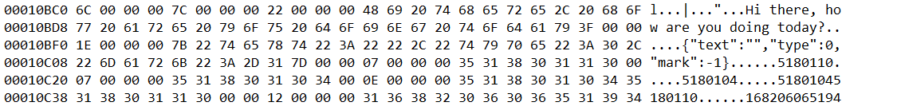



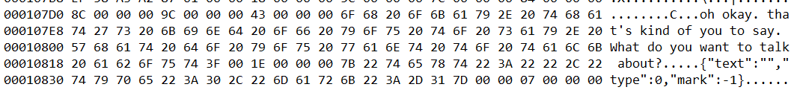

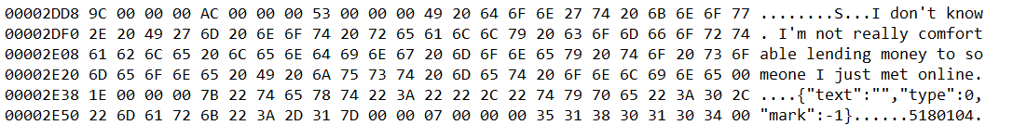

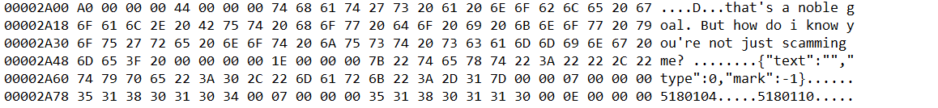

Evidence image included in the chat history where the suspect sends the bank information to the victim

[**https://chat-cdn.soulapp.me/image/2023-04-21/fde7f458-fc98-4389-b5d1-061339c810b9-1682061839194.jpeg**](https://chat-cdn.soulapp.me/image/2023-04-21/fde7f458-fc98-4389-b5d1-061339c810b9-1682061839194.jpeg)

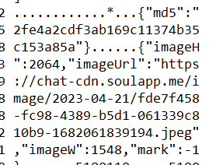

Evidence image included in the chat history where the victim send the money transaction screenshot to the suspects

[**https://chat-cdn.soulapp.me/image/2023-04-21/70b26961-1621-4c2e-9f5c-89a06cbdcb0a-1682061865172.jpeg**](https://chat-cdn.soulapp.me/image/2023-04-21/70b26961-1621-4c2e-9f5c-89a06cbdcb0a-1682061865172.jpeg)

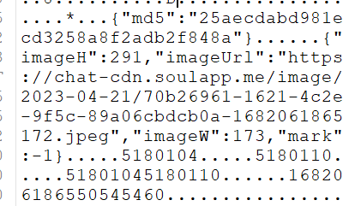

**Autopsy**

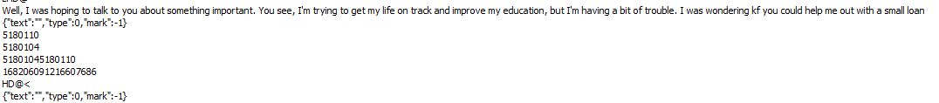

[**https://chat-cdn.soulapp.me/image/2023-04-21/fde7f458-fc98-4389-b5d1-061339c810b9-1682061839194.jpeg**](https://chat-cdn.soulapp.me/image/2023-04-21/fde7f458-fc98-4389-b5d1-061339c810b9-1682061839194.jpeg)

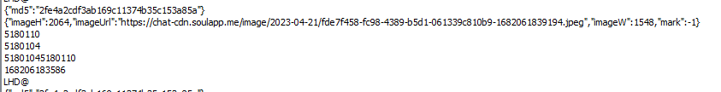

**https://chat-cdn.soulapp.me/image/2023-04-21/70b26961-1621-4c2e-9f5c-89a06cbdcb0a-1682061865172.jpeg**



